# **Cloud Data Centres: Lab 3**

By Sarah Martin

Student ID: C00257967

# **Part 2**

I started off by cloning a git repository from https://docs.docker.com/get-started/ into a folder called lab 3 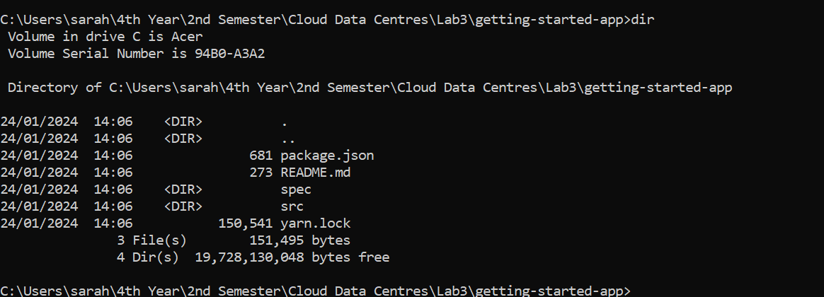

I then looked at the contents of the getting-started-app with this command



I created an empty Dockerfile and I opened it using Notepad.

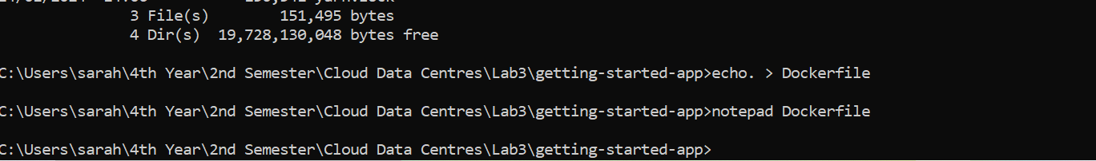

I added the following content to the Docker file.rfile

I then used this command to build the image.

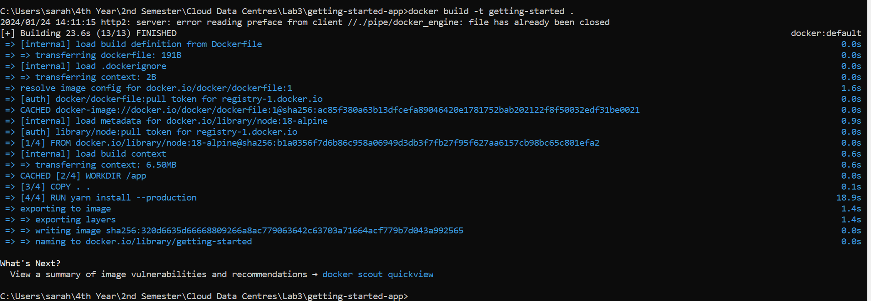

I then ran the container using this command.

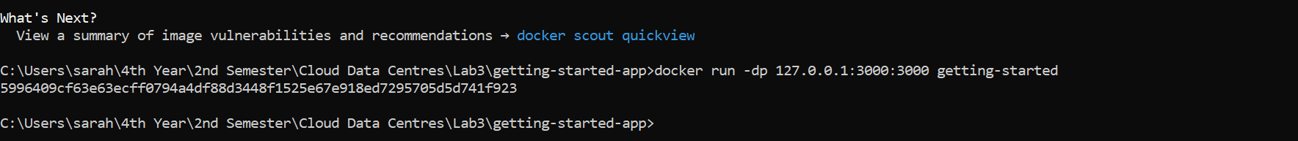

I now have this container in Docker running.

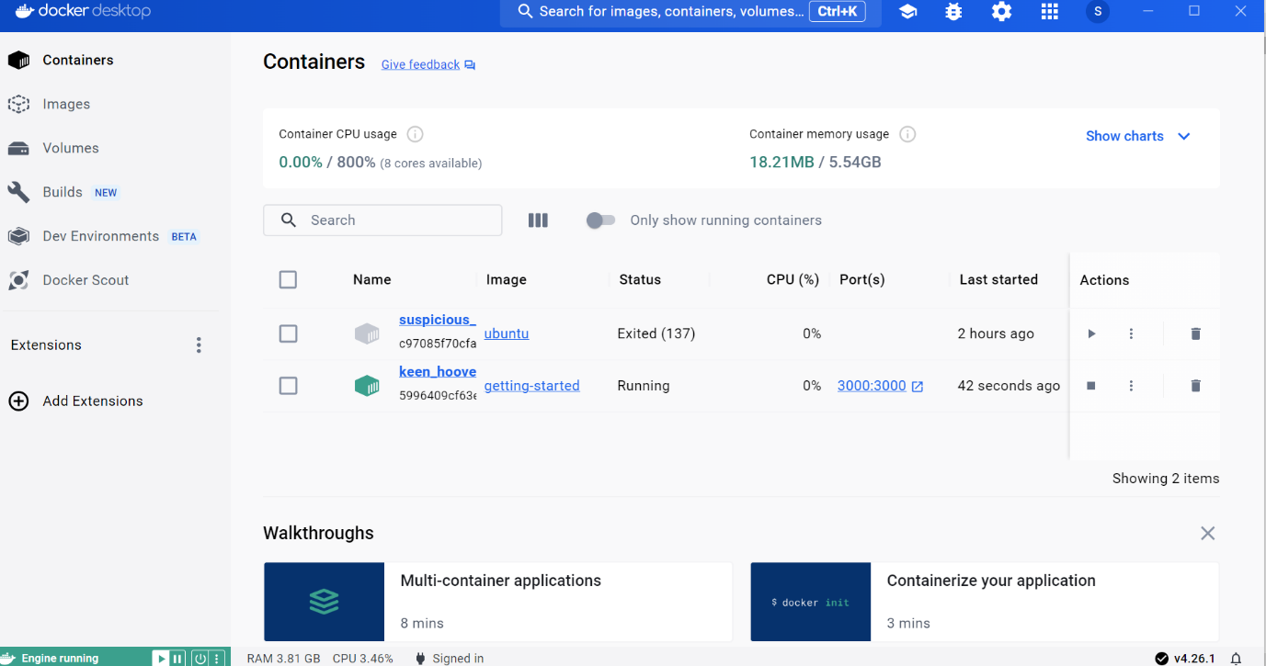



I now have this in my web browser <http://localhost:3000> and I have added some new tasks.

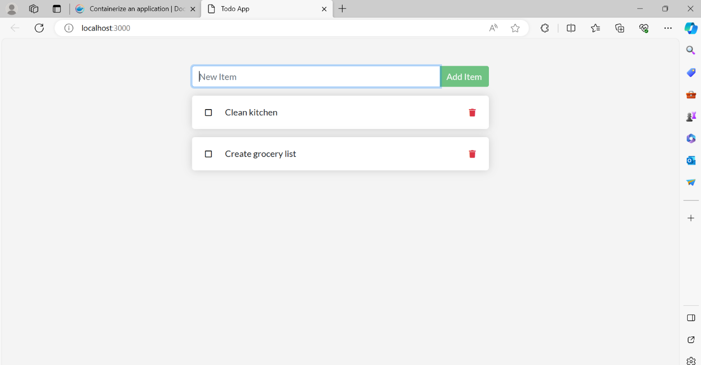

I ran the following command in the terminal to list my containers

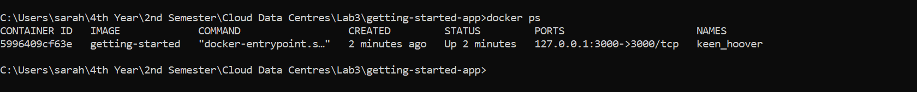

# **Part 3**

I edited the src/static/js/app.js file to update line 56 to include this.

